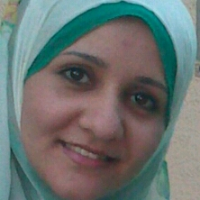
Marwa Kamel Mohammed Sayed

- Place of birth : Assuit .
- Social status : Married .
- Address : Assuit .Egypt
- Tel Mobile : 01023152692
Home : 088 / 2338741
- E-mail : drmarwa_kamel@aun.edu.eg
drmarwa_kamel@yahoo.com

EDUCATION :

- M.B.B.CH , 2009 .
Assuit University .
Grade : Excellent .

- Master degree in pediatric and neonatology , April 2014 .
Assuit university.
Grade : Excellent .

JOB :
Assistant lecturer in Neonatology unit in Pediatric Assuit university Hospital since 3 / 2011

EXPERIENT :

- House resident in Pediatric & Neonatology department in Assuit University Pediatric Hospital since March 2011 until March 2014 .

- Assistant lecturer in neonatology unit in Assuit University Pediatric Hospital since March 2014 until now.

CLINICAL CERTIFICATE :

- Basic & advanced mechanical ventilation in PICU & NICU , Assuit University.

